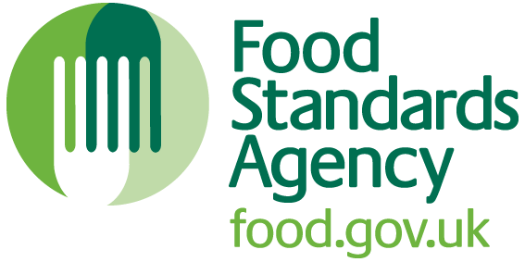

Inland Enforcement of Imported Food Controls
Resource Pack

England



Contents

Chapter 1: Overview of Imported Food Controls 4

Section 1- Introduction 5

Section 2 – Key Messages 7
2.1 Authorisation of Officers 7
2.2 Products of Animal Origin (POAO) 7
2.3 Foods not of Animal Origin (FNAO) 7
2.4 Role of Inland Authorities 8
2.5 Advice and Guidance 9

Section 3 – Imported food procedures 11
3.2 Imports from third countries: POAO 12
3.3 Imports from third countries: FNAO 13

Section 4 - Personal Imports 16
4.1 Personal Imports from Third Countries: FNAO 16
4.2 Personal Imports from Third Countries: POAO 16

Section 5 - Summary 17

Chapter 2: Inland Enforcement of Import Controls 18

Section 1 - Roles and Responsibilities 19
1.1 Enforcement Authorities at Ports 19
1.2 The Food Standards Agency (FSA) 19
1.3 Defra 19
1.5 Her Majesty’s Revenue and Customs (HMRC) / Border Force (BF) 19
1.6 Other agencies involved in imported food 20
1.7 Commercial Stakeholders 20

Section 2 – Legislation 22
2.2 Legislation relating to the importation of food from third countries: POAO 22
2.3 Legislation relating to the importation of food from third countries: FNAO 22

Section 3 – Role of Inland Local Authorities 23
3.1 Jurisdiction and right of entry 23

Section 4 – Liaison Arrangements with Points of Entry 25

Section 5 - Enforcement powers relating to POAO from third countries. 26

Section 6 – Regulation (EC) No 882/2004 on official control of food: Import conditions for FNAO from third countries. 27

Section 7 – The Official Feed and Food Controls (England) Regulations 2009 (as amended) 28

Section 8 – Inland checks on POAO from third countries 29
8.1 Identifying food as POAO 29
8.2 Verifying approved establishments and countries 30
8.3 Investigation Aide Memoir 31
8.4 Dealing with suspect or non-compliant food 32

Section 9 – Inland checks on FNAO from third countries 35
9.1 Expectations of local food authorities 35
9.2 Legislation 36
9.3 Right of Entry 36
9.4 Identifying foods as FNAO 36
9.5 Checks on FNAO 36
9.6 FNAO subject to enhanced import checks 37
9.7 Deferred Examination 37
9.8 Onward Transportation 37
9.9 Investigation Advice 37
9.10 Dealing with suspect food 38
9.11 Notifying the Point of Entry 39
9.13 External Temporary Storage Facilities (ETSF) 40

Section 10 – Summary 42

Chapter 3 – Case Studies 43

Case study 1: worked example 44
Case study 2 46
Case study 3 48
Case study 4 49
Case study 5 50

Imported Food Case Study Model Answers: 52
Model answer: Case study 2 53
Model answer: Case study 3 55
Model answer: Case study 4 56
Model answer: Case study 5 56

Chapter 4 – References 58

Section 1: Glossary 59
Section 2: Useful links 62
Section 3: National Contacts: 66

Chapter 1: Overview of Imported Food Controls
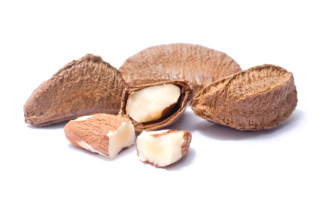

Section 1- Introduction

  - Resource Pack Aim

This pack aims to provide enforcement officials within local authorities in England with appropriate information, practical guidance and advice to enable them to secure the effective control of food imported into the UK. Please note parallel guidance will be available for Scotland, Wales and Northern Ireland.

  - Resource Pack Objectives

- To provide an overview of import controls in the - GB, including organisational roles and responsibilities.

- To provide up-to-date information for enforcement officials on current legislative controls.

- To describe the border control systems for both food products of animal origin (POAO) and food not of animal origin (FNAO).

- To advise authorities of their responsibilities for the enforcement of import controls and requirements for recording and reporting relevant information.

- To provide enforcement officials with information, practical advice and procedures to assist in the identification and control of illegal imports of food being distributed and offered for sale within the UK.

- To offer routes by which enforcement officials may raise and discuss enforcement and interpretation issues concerning imported controls.

- To facilitate better co-ordination of import controls across authorities.

- To provide a list of contact points and supporting information to food authorities relating to POAO and FNAO imports.

Please note that this Pack and the model forms (provided in the accompanying Annex 1) have been produced to explain the legal requirements for imported food control. Every effort has been made to ensure that the notes in this Pack are as helpful as possible. They cannot cover every situation and you should consider the relevant legislation itself to see how it applies in different situations.

The information in this Pack is regularly updated and takes into account Regulation (EU) 2017/625 on official controls performed to ensure the verification of compliance with feed and food law, animal health and animal welfare rules, the enforcement of which in England is provided for by the Official Feed and Food Controls Regulations (England) 2009 (as amended) (SI 2009/3255) (as amended). There is parallel legislation in Scotland, Wales and Northern Ireland.

  - Background

Imported food makes up an increasingly large part of the UK diet and about 50% of food consumed in the UK is from countries outside the UK. Imported food can be found in virtually every food business beyond the stage of primary production whether it be poultry from Brazil in the local take-away, strawberries from Egypt in the supermarket or vodka from Russia in the local sports and social clubs.

-
The majority of foods that are imported into this country are perfectly legal, wholesome and safe but it is important to have effective imported food controls in place to ensure that the consumer and food businesses are protected from contaminated products, unfair trading practices and fraud. It is the responsibility of the Competent Authorities (CA) to ensure that these controls are properly implemented.

Food enters the UK via seaports, airports and by road and rail through the Channel Tunnel. In GB, Port Health Authorities (PHAs) have been set up at seaports to undertake various public health duties including checks on certain imported foods and at airports Local Authorities (LAs) have this function. Throughout the UK, certain ports, which receive controlled products are designated as Border Control Posts (BCPs).

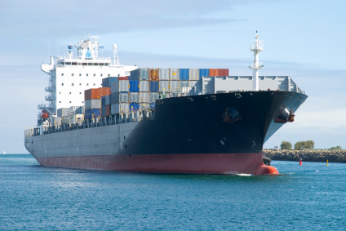

Section 2 – Key Messages

This Pack should be made available to all enforcement officers. LAs should have regard to the following points to ensure adequate controls are in place:

2.1 Authorisation of Officers

Authorities should ensure that officers are authorised in writing to enforce all relevant legislation. (See appropriate section of the Food Law Code of Practice (England) and the Food Law Practice Guidance (England) for further details).

2.2 Products of Animal Origin (POAO)

POAO include fresh meat, meat products, meat preparations, dairy products, fishery products, shellfish, egg products, honey, snails and insects.

Imported POAO is likely to be illegal if it was not presented to a Border Control Post (BCP) for required controls to be carried out, and/or if it does not comply with public or animal health requirements, such as being contaminated with veterinary residues.

It is an offence to introduce POAO into GB, except at a BCP unless the consignment is specifically exempted. Such exemptions include:

- Personal imports of certain POAO (Meat or Dairy products are prohibited) or:

- Trade samples that have received written approval from the Secretary of State.

- Other licensable goods

Further details on personal imports may be found on the Defra website: https://www.gov.uk/guidance/personal-food-plant-and-animal-product-imports

Persons who introduced illegal POAO into England have committed an offence and are liable to prosecution, the priority for inland food authorities is to identify such illegal products and remove them from the food chain.

2.3 Foods not of Animal Origin (FNAO)

For most FNAO, there are no requirements for pre-notification to border enforcement officers and inspections at the ports are based on risk assessment. As such it is important that inland checks are carried out to maintain public health safeguards.

A 'higher-risk' product is feed or food that is either a known, or emerging risk to public health. This may be due to the presence of contaminants and/or undesirable substances such as aflatoxins, heavy metals, pathogenic bacteria or pesticides. Imports of certain ‘higher-risk’ FNAO can only enter the UK through specific ports and airports approved as BCPs where official controls will be carried out.

Consignments of such products should be subjected to official controls by inland authorities to verify that they have been legally imported. Details of such products can be found at https://www.food.gov.uk/business-guidance/importing-high-risk-foods

2.4 Role of Inland Authorities

All importers should be identified and registered as Food Business Operators (FBOs). They should be included in the food intervention programme for the authority.

Establishments that are the first destination after import should be identified. These may include establishments used for storage, processing, and/or handling, buying or selling POAO or FNAO. Where the establishment is receiving POAO directly from a port, Common Health Entry Documents (CHED-Ps) should be available for each consignment. Where FNAO which are subject to the “Higher Risk” import controls as specified, for instance, in Regulation (EU) 2019/1793, are found at a first destination inland, a CHED-D should be present. Examples of the various CHEDs are shown in Annex 1 accompanying this Pack.

Import control legislation should be enforced as appropriate to the circumstances and in accordance with the authority’s enforcement policy.

Procedures relating to import control work should be developed in line with The Framework Agreement on Local Authority Enforcement, Food Law Code of Practice and Practice Guidance and Defra guidance documents.

Key enforcement notice templates should be readily available to authorised officers in case they are required. In particular, copies of the following notices (which can be found in Annex 1 of this Pack) should be readily available:

Official Feed and Food Controls Regulations (England) 2009 (as amended) (referred to throughout this Pack as the ‘OFFC Regulations’)

Regulation 32 Notice – To be used for the detention of suspect FNAO or destruction, special treatment or re-dispatch of FNAO that is illegally imported or is a risk to animal or public health.

Trade in Animals and Related Products (TARP) Regulations (England) 2011 (as amended) (referred to throughout this Pack as the ‘TARP Regulations’)

Regulation 32(6) – For the detention or seizure of suspect POAO, while under customs control, pending investigation
Regulation 19 – For the seizure of illegally imported POAO

Regulation (EU) 2017/625 – Letter of official detention for use with respect to POAO which is suspected to have been illegally imported from a third country Authorities should keep up to date with imported product issues. This can be achieved by visiting the FSA’s website: https://www.food.gov.uk/business-guidance/imports-exports

Authorities should ensure that all enforcement officers are aware of the system for reporting seizures of illegally imported POAO under Regulation 19 of the TARP Regulations, to Defra via DAERA, using the IIT1 form. The reporting of seizures by Local and Port Health Authorities requires the completion (preferably electronically) of a common form (IIT 1 (4/08)), which is then sent by e-mail for Defra to record the appropriate information. However, the option remains for the form to be completed manually, if that method is preferred, and sent to Defra by fax/post. Details of where to e-mail/fax/post the form is included on the form. A copy of the form can be found in Annex 1 accompanying this Pack. The form is located on the secure parts of the following websites which cannot be accessed without password permission:

APHA: http://www.porthealthassociation.co.uk
CIEH: http://www.cieh.org/

The information provided in this form is shared with the FSA’s National Food Crime Unit.

LAs responsible for food law enforcement at seaports, airports and at External Temporary Storage Facilities (ETSF) should ensure that their officers familiarise themselves with the following:

- Local stakeholders.
- Trade type (volume, variety, trade routes and freight handling agents).
- Relevant health and safety requirements.
- Relevant security requirements.

The police do not have any specific enforcement responsibilities under the legislation referred to in this Pack, but their assistance might be sought to aid PHAs/LAs or other inspectorates in their enforcement duties.

Authorised officers should consider imported food that is offered for sale by food businesses as a routine component of food hygiene and standards inspections. They should also investigate and take appropriate actions relating to (suspected) illegal imports, imports that may pose a risk to public or animal health and imports that fail to meet food safety requirements.

The Border Force (BF) has a specific procedure for passing information to the FSA on seizures of POAO destined for a commercial establishment. The FSA will verify that passing on the intelligence is in the public interest and then will refer cases to the relevant LAs for further investigation. It is important that the results of such cases are fed back to BF to help inform and refine risk profiling systems and for a complementary flow of information from inland LAs to BF via the FSA to inform the targeting of anti-smuggling checks at the border. In the event that such investigations become a significant burden on a LA, or the investigation is complex to the extent that programmed inspections need to be rescheduled, the LAs should immediately discuss the issue with the FSA to identify what assistance can be given.

2.5 Advice and Guidance

If in doubt at any time, authorities should contact the FSA Imported Food Team (email imported.food@food.gov.uk) and for POAO related advice, the Animal and Plant Health Agency (APHA) in Carlisle on 01228 403 600 (option 3) or by email at imports@apha.gsi.gov.uk. APHA is an Executive Agency of the Department for Environment, Food and Rural Affairs (DEFRA).

Finally, the underlying principle is that if you are in doubt then you should:

(a) Seek advice from colleagues,
(b) Seek advice from your own legal services and where appropriate
(c) Seek advice from FSA/Defra prior to taking action.

Section 3 – Imported food procedures

For the purpose of import controls, food can be placed into one of two categories: Products of Animal Origin (POAO) and Food not of Animal Origin (FNAO) and can be imported commercially from third countries.

The rules regarding the importation of food are different depending on the nature of the food (POAO or FNAO) and the country of origin:

3.2 Imports from third countries: POAO

In the UK, Defra is the Government department designated as the Central Competent Authority (CCA) for products of animal origin (excluding fishery products, bivalve molluscs, echinoderms, tunicates and marine gastropods for which the FSA has responsibility) and live imports in England. Agricultural departments in the devolved administrations of Scotland, Northern Ireland and Wales have competency in these countries.

POAO may only be imported from third countries that have received prior approval by the appropriate authority for the relevant type of POAO. In addition, the establishments involved in the handling of such food products must also be approved by the third country’s competent authority (CA) before the food can be lawfully imported to the GB.

The prior approval of third countries for POAO for export to the GB is undertaken by the appropriate authority which assesses the ability of the third country to produce products of an equivalent standard to those situated in the GB and the adequacy of the official controls performed by the third country’s CA. POAO, with some exceptions such as honey, must be produced in approved establishments and must be marked with the country of origin and a unique “establishment number”. The format of the establishment numbers applied to POAO can vary depending on the nature of the product e.g. dairy, meat or fishery products. A list of approved establishment numbers for POAO from third countries is available on the Commission website at:
https://ec.europa.eu/food/safety/international_affairs/trade/non-eu-countries_en

When exported from third countries, POAO are normally required to be accompanied by a health certificate signed by the CA of the third country to verify that the food meets the requirements of GB Law. The POAO must be pre-notified using Part 1 of the CHED-P by the importer or their representative (e.g. clearing agent) and must then enter the EU via an approved port known as a Border Control Post (BCP) where the food will be subject to veterinary checks by the relevant authorised officer. These veterinary checks will comprise, as appropriate; documentary, identity and physical checks.

Documentary Checks are carried out on 100% of consignments of POAO from third countries. A documentary check includes verification that the details on the health certificate and commercial documentation are correct and in line with EU requirements.

Identity Checks are carried out on most goods presented at BIPs, with a few exceptions. Some countries such as New Zealand and Canada have equivalency agreements in place with the GB which means that certain products from these countries undergo fewer identity and physical checks on entry to the GB. Where a product arrives in a sealed container and where provided for in GBlegislation, an identity check may be as simple as verifying that the seals are intact and that they correspond to the accompanying documentation. In other cases, an identity check will involve examining the consignment to verify that the products presented are the same as those covered by the health certificate and checking that the stamps and health marks identifying the country and establishment of origin are present and conform to those on the documentation.

Physical Checks may comprise several or all the following components:

- Temperature checks to ensure that the product still meets the requirements as described in the accompanying health certificate e.g. is chilled, frozen or ambient.
- Sensory (visual, odour, taste).
- Thawing and cooking.
- Wrapping & labelling.
- Packaging integrity.
- Bacteriological quality.
- Analysis for contaminants, bio-accumulative compounds/toxins and prohibited substances (e.g. growth promoters).
- Transport conditions including thermograph records.
- Evidence of damage or alteration, evidence of pest infestation or contamination etc.

Physical checks are not carried out on all consignments; their frequency is dependent on the nature of the food and the country of origin. Council Regulation (EU) 2017/625 as amended lays down principles governing the organisation of veterinary checks on products entering the EU from Third Countries (https://eur-lex.europa.eu/legal-content/EN/TXT/PDF/?uri=CELEX:02017R0625-20191214&from=EN).

Veterinary checks are carried out by Official Veterinary Surgeons (OVS) or Official Fish Inspectors (OFI) working at the BCP. Once the veterinary checks have been successfully completed, the OVS or OFI will complete, sign and stamp Part II of a CHED-P to demonstrate that the food has been subjected to the appropriate official controls and has been released for free circulation within the GB. This CHED-P must accompany the POAO to its first destination inland where it should be retained for a period of one year.

Should the products fail the veterinary checks, the POAO may be destroyed or re-dispatched to the country of origin, under the provisions of the TARP Regulations, depending on the reason for the failure. Alternatively, the product may be used as an animal by-product in accordance with Regulation (EC) No 1069/2009. Part II of the CHED-P will be completed to indicate that the product and/or the controls were unsatisfactory.

There may be occasions whereby the POAO enters the GB via a BCP but its destination is outside of the GB In these circumstances, special provisions apply. Once cleared by the BCP, food may be sent through to a “Customs Warehouse” or External Temporary Storage Facility (ETSF) prior to HM Revenue and Customs (HMRC) checks. Further information on ETSF is available in Section 9.13 of this Pack.

3.3 Imports from third countries: FNAO

Most FNAO imported from third countries are not subject to routine checks at the points of import. Whilst there is a requirement that all products meet at least the required standards of retained European Law, in practice most of the official controls conducted by ports are targeted at FNAO that present a higher risk to public health.

Such products include nuts and dried fruits from certain countries with a history of mycotoxin contamination of feed and foods, as well as products which may be contaminated with other contaminants for example Salmonella or pesticides.

At present there are no arrangements, as is the case with POAO, for the approval of third countries and establishments which supply FNAO to the GB. However, import conditions drawn up under Regulation (EU) 2017/625 provide for certain “higher risk” FNAO to only be imported via BCPs, to be accompanied by a CHED-D and to be subjected to verification sampling, where appropriate, at the port to ensure that they comply with food standards.

Any food (and feed) listed in Annex I of Regulation (EU) 2019/1793 (as amended bi-annually) is considered to be a known or emerging risk and subject to the enhanced import controls. Once such food (and feed) has been subjected to the appropriate official controls, Part II of the CHED-D is completed by the BCP. This must accompany the consignment inland to the destination of the consignment. The consignment must be notified in advance, at least one working day prior to the physical arrival of the consignment, to the BCP. This must be done using Part I of the CHED-D by the Importer or their representative e.g. Clearing Agent. All must undergo a documentary check and a percentage undergoes identity and physical checks (including sampling).

The Regulation also contains emergency measures where there is concern about certain products from certain third countries, which may prohibit their importation or impose additional import controls on such products. These consignments must be accompanied by the results of sampling and analysis as carried out by the competent authority in the country of origin or the country of dispatch if different. They must also be accompanied by a health certificate and enter via a BCP. These goods must be notified by the Importer or his representative in advance to the BCP using Part I of the CHED. For example, products listed in Annex II are subject to additional controls at the BCP which will then complete Part II of the CHED-D once the controls are complete.

In summary, POAO imported from third countries must enter the EU via a BCP.

FNAO may enter the GB through any port except those "Higher Risk" FNAO including, for example, those listed in Regulation 2019/1793 must enter via a BCP (for a list of UK BCPs see: https://www.gov.uk/government/publications/uk-border-inspection-posts-contact-details/live-animals-and-animal-products-border-control-posts-bcp-in-the-uk).

This is summarised in the diagram below:

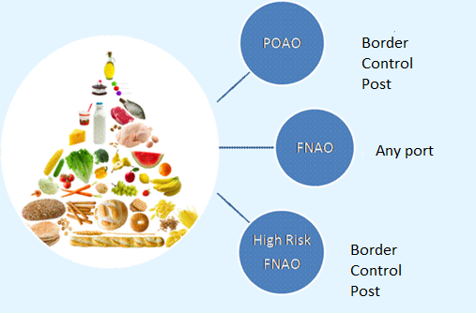
Points of import into the GB of food from third countries

BCPs will complete CHED-Ps for POAO imported from third countries and CHED-Ds for "higher risk" FNAO. In both cases, the documents must accompany the food to the first destination inland.

Section 4 - Personal Imports

During serious outbreaks of disease, emergency legislation may be introduced to increase controls if necessary. However, restrictions are in place in relation to foods imported from third countries but these vary depending on the type of food involved, except for kava-kava, whose import is prohibited.

Personal imports will include foods brought back by travellers in their luggage or sent to a private, named individual either by post, courier service or private carrier (including those ordered online). Any food posted to a commercial address will, in law, be considered to be a commercial import and will, where appropriate, be subject to import control rules.

4.1 Personal Imports from Third Countries: FNAO

Members of the public can bring back reasonable quantities of food that does not contain anything of animal origin. For large amounts, if it is considered to be for commercial purposes then it may be subject to checks by the port health authorities at the point of entry.

Personal imports of fruit and raw vegetables from outside the GB may be subject to a limit of 2kg due to plant health restrictions except personal imports of potatoes, which are prohibited. Information on what fruit and vegetables are restricted and which are not restricted are available on the Animal and Plant Health Agency (APHA) website which can be accessed at:
https://www.gov.uk/bringing-food-animals-plants-into-uk/plants

In GB, enforcement responsibilities for personal imports rest with HMRC Officers. In NI, this responsibility rests with DAERA.

4.2 Personal Imports from Third Countries: POAO

Personal imports of meat, meat products, milk and milk products are banned from most countries outside the EU, with limited exceptions. Up to 20kg as a combined weight for all fishery products from approved countries (with the exception of caviar from sturgeon species whose limit is 125g) or the weight of one fish, whichever is the highest and 2kg as a combined weight of ‘other animal products’ such as honey, eggs, egg products, live bivalves, snail meat (edible land snails, shelled), reptile and insect meat and frogs’ legs. However, they must come from a country that is approved to export to the GB.

Further information regarding personal imports can be found on the Defra website, https://www.gov.uk/guidance/personal-food-plant-and-animal-product-imports

The Personal Import Rules database can be accessed for a product specific check of personal imports that are permitted in the UK and those that are not: http://importdetails.defra.gov.uk/Default.aspx?Location=None&Module=IDDSearch

Section 5 - Summary

For the purposes of imported food control, foods are classified as either POAO or FNAO and can enter the UK from third countries or as personal imports.

POAO imported from third countries are subject to the most stringent controls. Foods can only be imported from approved third countries and, with some exceptions (such as honey), from an approved establishment. They must be accompanied by an official certificate signed by the relevant CA in the exporting third country to verify that the goods have been produced in equivalent standards to those in the GB These products and can only be imported into the GB through an approved port of entry (a BCP) where the food is subjected to veterinary checks by an appropriate authorised officer.

Once these checks have been completed, a CHED-P is completed which must accompany the food to the first destination inland. POAO from approved establishments must be marked with the Country of origin and a unique “establishment number”.

FNAO are not subject to the same level of import controls. However, certain “Higher Risk” FNAO from third countries can only be imported into the GB via BCPs and may be required to be accompanied by official and analytical certificates. Under emergency measures, once the food has been subjected to official controls, a CHED-D is completed which must accompany the food to the first destination inland.

Personal imports from third countries are generally permitted however, imports of meat and dairy products are banned, and restrictions apply to other POAO such as fishery products.

Chapter 2: Inland Enforcement of Import Controls

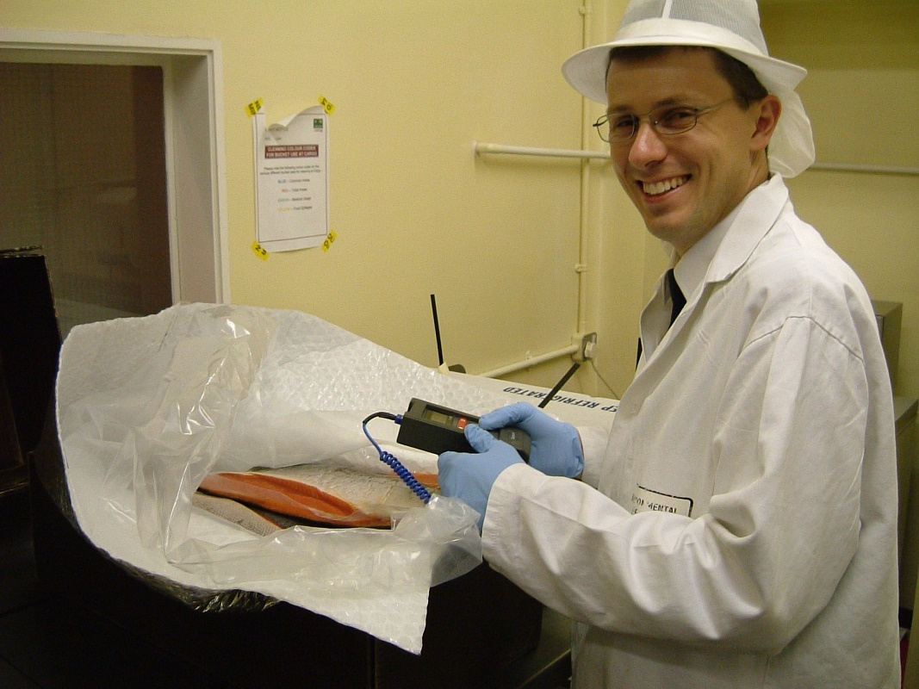

Section 1 - Roles and Responsibilities

Enforcement Authorities at Ports

LAs and PHAs are responsible for food safety and standards checks on imported products at points of entry. Such examinations include veterinary checks on POAO from third countries presented at BCPs as required by GB law. LAs are also responsible for checks inland.

LAs are not responsible for detecting smuggled POAO (other than when such POAO are found in a BCP facility). This responsibility falls to Border Force (BF). However, LAs, except County Councils, are responsible for dealing with illegal POAO (including smuggled goods) when discovered inland at retail, catering, market stalls or other premises.

1.2 The Food Standards Agency (FSA)

The FSA is the CCA concerned with public health aspects of food, contamination of food and the systems for the notification of food and feed risks. The FSA has a dedicated Imported Food Team that may be consulted as a source of information and advice, as well as regional offices for the devolved administrations.

1.3 Defra

The Department for the Environment, Food and Rural Affairs (Defra) is the CCA with respect to POAO in GB other than fishery products and shellfish for which the FSA is the lead.

-

1.5 Her Majesty’s Revenue and Customs (HMRC) / Border Force (BF)

In GB HMRC / BF enforce the requirements in relation to illegal imports of POAO (in Customs approved areas other than BCPs). They carry out conformity checks on foods to ensure that appropriate import duty is paid and that any sanctions, restrictions or prohibitions are enforced or controlled appropriately. Checks are also carried out on export consignments.

The clearance function is delivered by HMRC’s National Clearance Hub (NCH) via the electronic freight clearance system known as CHIEF (Customs Handling of Import and Export Freight). BF is responsible for carrying out risk-based anti-smuggling controls on illegal importations of POAO at GB points of entry (except in BCPs) and are deployed on a mobile and flexible basis with the support of detector dogs specifically trained to detect POAO. They are also responsible for enforcing controls on importations of endangered species (and products derived from them) under the Convention on International Trade in Endangered Species (CITES).

1.6 Other agencies involved in imported food

Other agencies involved in the control of imported food include:

Maritime and Coastguard Agency (MCA)

The MCA is responsible for enforcement of safety and standards on vessels. It carries out a wide range of functions with the overall aims of preventing loss of life, continuously improving maritime safety and protecting the marine environment. The MCA also has an important role regarding development of port waste management plans and ensuring adequate facilities for the disposal of ship and other port waste, including food waste. This is extremely important in terms of animal health protection, as food waste from ships is a possible vector of animal disease. Such waste must be disposed of by incineration or landfill (subject to specific conditions).

Medicines and Healthcare Products Regulatory Agency (MHRA)

The MHRA is the UK Governmental executive agency that controls and licences medicines for human use. In simple terms, if a product for human consumption is not licensed by the MHRA as a medicine, then by default it will generally be classified as a food.

Association of Port Health Authorities (APHA)

APHA is a UK wide organisation representing the interests of LAs and PHAs with responsibilities for health controls at sea/ airports and has the primary objective of preventing the introduction into the country of dangerous epidemic, contagious and infectious diseases as well as ensuring the
wholesomeness of imported food.

1.7 Commercial Stakeholders

A number of bodies, organisations and individuals are involved in the process of importing food and each have a responsibility to ensure that imported food meets the requirements of law. These include:

Importers

Importers generally hold a legal responsibility for compliance with the legislation relating to imported food, plants and plant products, although certain regulations have definitions that establish other responsible persons, e.g. ‘person-in-charge’.

Agents

It is normal practice for importers to appoint a local clearance agent or customs clearance agent. The agent will act on behalf of the importer to make statutory declarations, liaise with enforcement officials, obtain clearance of goods from the HMRC National Clearance HUB in Salford and arrange delivery of goods to the consignee.

Port Operators

The commercial administrators of port functions, including dock operations and leasing of storage, warehousing and office accommodation, etc.

Harbour Authorities

Established to control shipping movements, speed limits and shipping operations within a defined port area.

Airlines/Shipping Lines

Commercial owners/operators of ships/aircraft.

Section 2 – Legislation

The legislation that provides a regulatory framework for the importation of food is organised according to the nature and origin of the food. Authorities should ensure that officers are authorised in writing to enforce all relevant legislation. (See appropriate sections of the Food Law Code of Practice (GB) for further details).

2.2 Legislation relating to the importation of food from third countries: POAO

POAO may only be imported into the GB in accordance with Regulation 2017/625 which sets out the requirements for veterinary checks. The Regulation is implemented and enforced in England by the Trade in Animals and Related Products Regulations 2011 S.I. No. 1197 (TARP Regulations) (as amended) and equivalent legislation in Northern Ireland and Wales.

Defra as the CA for POAO, has provided guidance (See Annex 1 accompanying this Pack) for enforcement authorities within England responsible for enforcement of imported food inland. The aim of the guidance is to explain key elements of the TARP Regulations and how these regulations are applied and fit with other existing domestic and EU legislation.

This Pack provides advice on compliance with the requirements of TARP Regulations that give effect to legislation concerning the importation of POAO.

2.3 Legislation relating to the importation of food from third countries: FNAO

The import conditions relating to FNAO from third countries are provided by Regulation 2017/625. This Regulation requires that CAs undertake official controls of FNAO at the point of entry into the GB or at any stage during distribution. These official controls should include documentary, identity and where appropriate physical checks (including sampling) of the food. Any suspect food that is detained by the CA and any food which fails to meet the requirements of GB law should be destroyed, re-dispatched, or where appropriate, used for a non-food purpose or subjected to special treatment to render it lawful.

The import conditions provided by Regulation 2017/625 are executed and enforced in England by the Official Feed and Food Controls Regulations (England) 2009 (as amended). These Regulations identify the appropriate enforcement agencies and provide authorised officers with powers of entry and powers to inspect relevant products. They also provide for an enforcement notice to be served to allow for suspect food to be detained or unlawful food to be dealt with in accordance with the requirements of Regulation 2017/625.
Section 3 – Role of Inland Local Authorities

Authorised officers working for inland LAs should ensure that their routine food hygiene, food standards inspection and complaint investigation work takes into account imported food issues. It is recommended that priority is given to POAO and higher risk FNAO from third countries that may have been illegally imported.

Some suggestions on the steps that LAs could take to verify the adequacy of imported food controls in their areas for products from third countries might include:

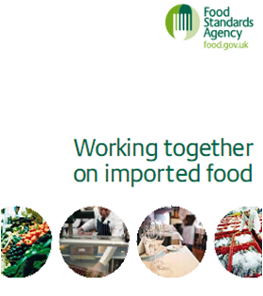
- Identifying importers of food in their areas.
- Identifying establishments in their areas which are the first destination inland for imported food.
- Check the traceability of imported foods.
- Verify the validity of third country establishment numbers.
- Approved residue plans
- IUU Requirements
- Raise awareness of imported food matters among:
  - Local food trade
  - Members of the public
- Where non-compliance is found, take appropriate enforcement action.
- Communicate with other enforcement agencies including LAs/PHAs at points of entry.

All local authorities should provide data on imported food control via the Local Authority Enforcement Monitoring System (LAEMS). This includes both points of entry and inland authorities. Where samples are taken of imported food, even at catering or retail level, data should be entered in the samples part of the imported food section of LAEMS. The Agency has produced guidance on the completion of LAEMS returns for imported food and this can be accessed via the FSA Smarter Communications platform at:

https://smartercommunications.food.gov.uk/resource/folders/70

3.1 Jurisdiction and right of entry

BF is responsible for the enforcement of POAO controls in ETSF and Inland Clearance Depots, while HMRC have overall responsibility for import policy and procedures. When inspecting or visiting food business premises, officers should determine whether the facility is under BF/HMRC control (e.g. airside at an airport, at an ETSF, within dock gates or an HMRC fence at a seaport). BF are responsible for carrying out specific searches for illegal imports of POAO in HMRC controlled areas and therefore the LA does not have jurisdiction.

In all other food business premises under LA jurisdiction, any imported POAO should routinely be assessed to determine if it has been legally introduced and meets appropriate food safety requirements. Under regulations 33 and 34 of the Trade in Animals and Related Products Regulations 2011 (TARP Regulations), food enforcement officers have a right to enter any BCP or other land or premises (except private dwellings where a warrant is required prior to entry) to inspect these areas or anything located in or on these areas.

Please note that Trading Standards Officers (TSO) working at County Council level are not authorised to undertake food enforcement action under the Trade in Animals and Related Products Regulations 2011.

Where a TSO identifies illegally imported POAO (food) from a third country during their routine work, the matter should be referred to the relevant District Council Environmental Health Department for action.

Section 4 – Liaison Arrangements with Points of Entry

Whenever inland LAs identify problems with imported food they should, wherever possible, inform the authorities at the point of entry if they consider that similar problems are likely to be found in future imported consignments.

In certain circumstances, it will be necessary for authorised officers at points of entry or at an ETSF to refer imported food matters to inland LAs.

It is recommended that representatives from the ports are invited to food liaison group meetings to share intelligence and provide updates on current imported food issues to inland authorities. Contact details for all of the UK ports are available on the APHA website at: http://www.porthealthassociation.co.uk/.

Whenever a matter is referred by a port to an inland LA, every effort should be made to update the port on any subsequent action taken.

Section 5 - Enforcement powers relating to POAO from third countries.

The Trade in Animals and Related Products Regulations 2011 (TARP Regulations) provide for the following enforcement notices which may be used, where appropriate, by inland authorised officers:

Regulation 19 notice:

The powers of inland seizure in Regulation 19(1) of the TARP Regulations only apply where POAO from third countries has not been properly processed and cleared through a BCP or at the destination specified in Part II of the CHED-P. The use of this notice is appropriate where the officer is satisfied that the POAO in question has been illegally introduced into the country.

Regulation 19 Notice: The use of this notice to seize a consignment is appropriate where the officer is satisfied that the POAO in question has been illegally introduced into the country.

Regulation 32(6) notice: This notice should be used where an authorised officer of an inland LA seeks to detain a product he suspects to be an illegal POAO from a third country in an ETSF.

Defra advise that where an authorised officer from an inland authority suspects that a POAO has been illegally imported from a third country, the officer may issue a letter of official detention, in accordance with Article 65, Regulation 2017/625, to the person who appears to be in charge of the food. This letter may require that the food is detained in situ or removed to a place specified in the letter where it will remain until the results of official controls are known or investigations have concluded. A template letter of official detention is available in Annex 1 of this pack.

Where an enforcement officer wishes to seize, detain or require the disposal of POAO from third countries which are suspected of presenting a danger to health or being unfit for human consumption despite being properly cleared for import, he/she should consider the use (where appropriate) of other sanctions, such as:

- Section 9 of the Food Safety Act 1990 (detention/seizure of food failing food safety requirements)

- Regulation 25 of the Animal By-Products (Enforcement) Regulations (England) 2013 (storage and disposal of animal by-products)

Where an enforcement officer is satisfied that a POAO has been illegally introduced, they should take appropriate action as outlined in Regulations 19 and 20(3) of the TARP Regulations. An authorised officer should seize the consignment or products and either:

- Have it re-dispatched, by the mode of transport by which it was first introduced into the GB, to a destination in a third country within sixty days
OR

- Have it dispatched for rendering or incineration as category 1 material in accordance with relevant animal by-products legislation.

Section 6 – Regulation 2017/625 on official control of food: Import conditions for FNAO from third countries.

Chapter V of Regulation 2017/626 sets out the import conditions for FNAO imported from third countries. The main provisions are:

Article 44: This article requires that the competent authority undertakes official controls on FNAO and outlines how this is to be achieved by means of a National Control Plan. These official controls should be undertaken at all stages of import and distribution.

Article 54also provides for a list of known or emerging risk FNAO that is to be subject to an increased level of official controls. These provisions are implemented by Regulation 2019/1793.

Article 45: Defines official controls for FNAO imported from third countries as: Documentary, Identity and Physical checks.

Article 65: Requires that where FNAO is suspected of being non-compliant with EU law, it should be placed under detention pending the results of official controls.

Article 66: Provides for various actions to be taken to deal with non-compliant FNAO.

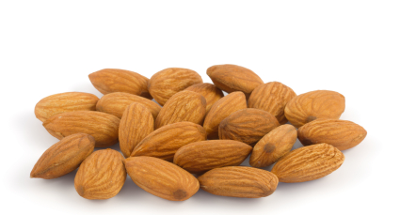

Section 7 – The Official Feed and Food Controls (England) Regulations 2009 (as amended)

The Official Feed and Food Controls (England) Regulations 2009 (as amended), or “OFFC Regulations” provide the enforcement arrangements for the import conditions of Regulation 2017/625.

The OFFC Regulations can be used by inland local authority officers to deal with non-compliant FNAO which has been imported and they include the following arrangements:

- Deferred Execution and Enforcement
- Prohibition on introduction of FNAO into England
- Detention, Destruction, Special Treatment etc of non-compliant FNAO
- Notices pursuant to Article 66 of Regulation 2017/625.

Regulation 32 of the OFFC Regulations provides for an enforcement notice which may be used to detain any FNAO from a third country where there is suspicion regarding its compliance with food law or the way it was introduced into England. The notice may also be used to arrange for the food to be:

- Destroyed
- Re-dispatched
- Subjected to a “special treatment”
- Used for non-food purposes
- Withdrawal or recall from the market.

A Regulation 32 notice should be served on the FBO who must be consulted prior to such service, however the FBO does not need to be consulted regarding detention under Regulation 32(1). Where the FBO is aggrieved by the service of a Regulation 32 notice, he/she may appeal in the first instance to the Magistrates Court and, where appropriate, subsequently to the Crown Court.
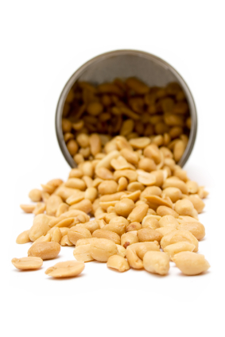
A copy of this notice is available in Annex 1 of this Pack.

Section 8 – Inland checks on POAO from third countries

Traceability checks should form the basis of most Food Hygiene and Food Standards Interventions by LAs. It would be prudent for authorised officers inland to consider foods imported from third countries when undertaking such checks.

Most POAO (except for example honey) imported from third countries should be marked with the country of origin together with the approval code or “establishment number” of the third country establishment responsible for producing the food. This establishment number should be available at all stages of distribution, including retail.

Whilst most canned and packaged POAO will normally bear the establishment mark on packaging (for example on the can itself, on any subsequent wrapping or label), it is not uncommon for authorised officers to find unmarked food on sale in retail and catering establishments.

Under such circumstances, officers should look for any remnants of packaging or any documents which may bear the establishment number. Where reasonable efforts have failed to identify a valid establishment number, officers should consider taking appropriate enforcement action.

Where establishment numbers are available on POAO imported from third countries, officers should take steps to verify the validity of these numbers.

It should be noted that the establishment numbers for certain composite products may not be those listed as EU approved POAO establishments on the Commission’s website. A composite product is a foodstuff containing both processed products of animal origin and products of plant origin. Composite products containing less than 50% of processed egg and egg products, honey, fish and fishery products may come from any non-EU countries (unless subject to a prohibition under an EU safeguard measure) and are not required to come from an approved establishment listed on the Commission website for POAO imports. This applies where these composite products are shelf stable at ambient temperature or have undergone in their manufacture a complete cooking or heat treatment process so that the raw material is denatured, clearly identified as for human consumption and securely packaged or sealed in clean containers. This also applies where composite products contain less than 50% of processed milk products and these conditions are met. However, the milk product content must come from an EU approved country.

8.1 Identifying food as POAO

Some imported POAO foods may be unfamiliar to enforcement officers and the product packaging may be entirely in a foreign language. Therefore, it may be unclear whether or not the product is a POAO or a FNAO. If the type of product is unclear, enforcement officers are encouraged to take photographs/descriptions of the product as appropriate and seek advice from FSA/Defra.

If the product cannot be identified by FSA/Defra, enforcement officers should consider sampling the product under regulation 34(g) of the TARP Regulations 2011. However, if there is reasonable belief that it is not POAO then Regulation 32 of the OFFC Regulations may be used to detain while investigating.

Identification aids

A key identification aid for POAO is the identification mark or “establishment number”. Here are some general rules to assist in verification of identification marks on POAO:

Fishery Products and Bivalve Molluscs

Fishery products must have an identification mark as described in Section I of Annex II of Regulation (EC) No 853/2004 on hygiene rules for food of animal origin and must have:

- Country of origin marked on the packaging, either in full or as a two-letter code (in accordance with the ISO standard country code).

- Establishment EU Approval Number. The establishment number is usually a simple printed number generally with an ‘EU Est.’ prefix, but this may not be present. The establishment number can sometimes be found embossed on canned goods, ink printed on glass or just incorporated on the label. Some goods carry two sets of establishment numbers, the second one pertaining to domestic rules in the third country and should be ignored. If the number is not immediately apparent have a close look. The FSA’s website contains further information on the fishery products at https://www.food.gov.uk/business-guidance/importing-fishery-products-or-bivalve-molluscs.

Meat Products

Regulation (EC) No 853/2004 defines meat products as meaning, “processed products resulting from the processing of meat or from the further processing of such processed products, so that the cut surface shows that the product no longer has the characteristics of fresh meat”. The terms ‘processing’ ‘unprocessed products’ and ‘processed products’ are defined in Article 2(1) (m), (n) and (o) respectively of Regulation (EC) No 852/2004.

The term "health mark" is reserved for fresh meat carcasses and primal cuts – excluding poultry meat.

Under Article 18(4) of Regulation 2017/625a health mark is required on carcases of cattle, deer, goats, horses, pigs and sheep. This must be in the form of an oval mark at least 6.5 cm wide by 4.5 cm high and must include within it the name of the country in which the establishment is located which may be written out in full, in capitals or shown as a two-letter code in accordance with the relevant ISO standard, together with the approval number of the establishment. Letters must be at least 0.8 cm high and figures at least 1 cm high. The dimensions and characters of the mark may be reduced for health marking of lamb, kids and piglets. The colours used for health marking must be authorised in accordance with retained EU rules on the use of colouring substances in foodstuffs. The mark must be applied in such a way that if the carcase is cut into half or quarters or if a half carcase is cut into three pieces, each piece bears a health mark.

8.2 Verifying approved establishments and countries

Approved establishments for different categories of POAO can be verified on the European Commission (EC) website at:

https://webgate.ec.europa.eu/sanco/traces/output/non_eu_listsPerActivity_en.htm

Exceptionally, there are some establishments that may not be listed on the main website. Please ask Defra/FSA if you are uncertain.

8.3 Investigation Aide Memoir

The flow charts provided in Annex 1 of this Pack may assist enforcement officers in carrying out imported food checks and officers may wish to determine or consider the following points:

Identification:

- Can the product be identified at the premises?
- Ask about use, origin and ingredients.
- Novel foods should have been approved. A novel food is defined as a food or food ingredient that does not have a significant history of consumption before 15 May 1997. More information is available at: https://www.food.gov.uk/business-guidance/novel-foods.
- Consider the use of digital photography so pictures can be e-mailed to Defra/FSA, if necessary.

Origin/safety/condition of the food:

- Has it been imported from a third country and if so, where from?
- Does it carry appropriate health/establishment marks?
- Does it appear to be fit for consumption?
- Is it appropriately packaged/labelled/temperature controlled?
- Approved residue plans

NB: Some products are designed to look as if they are imported even though they are legitimately produced in the GB, e.g. some brands of pork luncheon meat that carry the same brand name as similar Chinese origin product and beef jerky.

Traceability:

- Has the retailer got records relating to whom and from whom the goods were purchased? (See regulation 19(1) and Schedule 2 of the Food Safety and Hygiene (England) Regulations 2013, which enforce the traceability requirements of Article 18(2) and (3) of Regulation (EC) No 178/2002).
- Do invoices/receipts etc. tally with goods on sale?
- If premises are the first destination after import, are there CHED-P documents for the last year?
- Can the products be traced to the BCP of entry?
- Trace source of the goods as far as possible (this may involve several steps up the distribution chain).

NB: If no CHED-P is available, you should be able to verify the legal introduction into the GB by either contacting the BCP of entry or tracing the goods back to the point of entry using information such as invoices, shipping container or airway bill numbers for the consignment. Enforcement officers will need to note as many details as possible for the consignment and quote those when contacting the BCP. In some cases, this may be in another Member State, in which case FSA should be contacted in accordance with section 2.4 of the Food Law Code of Practice.

Note that in cases where an illegal importation of POAO has been found inland, HMRC should be informed at an early stage by contacting HMRC National Co-ordination Unit. Enforcement Officers wishing to pass intelligence reports on suspect POAO to HMRC, should send these to the Border Force National Intelligence Hub on Tel. 03000 583 016 or UKBFNationalIntelligenceHub@homeoffice.gov.uk

Responsibility:
- Identify the person in charge of the goods (usually the retailer).
- Request documents and relevant information from the person in charge (using powers under regulation 34 of the Trade in Animals and Related Products Regulations 2011, (TARP Regulations) if necessary).
- If faced with lack of co-operation there is an offence of obstruction provided for under regulation 36.

8.4 Dealing with suspect or non-compliant food

The flow diagrams provided in Annex 1 of this Pack may assist enforcement officers in taking appropriate enforcement action. The burden of proof is on the LA to demonstrate that:

- POAO has been illegally introduced (Regulation 13 of the TARP Regulations); or
- POAO does not meet food safety requirements, i.e. it is unsafe within the meaning of Article 14 of Regulation (EC) No 178/2002 as enforced by the Food Safety and Hygiene (England) Regulations 2013.

Illegally introduced products

If you are satisfied that the product has been illegally introduced (e.g. checks at a BCP have been evaded), you must seize the product by issuing a notice under regulation 19 of the TARP Regulations, on the person appearing to have charge of the product. The officer should by such notice, seize the product and either have it disposed of (either by rendering or incineration) as if it were Category I material under Regulation (EC) No 1069/2009, or re-dispatch it within 60 days to a destination in a third country, by the same mode of transport by which it was first introduced to the GB. Although the final decision rests with the enforcing authority, in most circumstances it is unlikely to be appropriate or practical to re-dispatch the products.

Products not meeting food safety requirements

Officers may, in some circumstances be unable to use regulation 19 of the TARP Regulations to deal with illegal products even though there are concerns about food safety. If the product does not meet food safety requirements i.e. is unsafe (as defined by Article 14 of Regulation (EC) No178/2002), it may be seized under Section 9 of the Food Safety Act 1990.

When food has not been produced, processed or distributed in accordance with the Hygiene Regulations (which are defined in the Food Safety and Hygiene (England) Regulations 2013 and include these domestic regulations as well as the EU retained Hygiene Regulations, namely Regulation 852/2004, Regulation 853/2004, Regulation 2017/625, Regulation 2073/2005 and Regulation 2015/1375) and it is appropriate, consideration could be given to the use of Regulation 29 of the Food Safety and Hygiene (England) Regulations 2013.

Voluntary Surrender

Voluntary surrender may be an option depending on the circumstances. However, you should note that the TARP Regulations require service of a formal notice when you are satisfied that the product has been illegally imported and voluntary surrender is not permitted when serving a Regulation 19 notice under these Regulations.

Detention or Seizure of POAO inland

If an officer wishes to detain or seize any product of animal origin inland to investigate further to establish its safety or compliance, voluntary co-operation should be sought in the first instance. In situations where this is not possible or is inappropriate due to risk, there are provisions under Article 65 of Regulation 2017/625 for an authorised officer to detain the product until such a time as the investigation is complete. A detention/seizure notice template is also available in Annex 1.

Where an authorised officer is satisfied that a POAO has been illegally introduced, they should take appropriate action as outlined in Regulations 19 and 20(3) of the TARP Regulations. An authorised officer should seize the consignment or product and have it re-dispatched or destroyed in accordance with the guidance produced by Defra (see Annex 1).

Legal imports subsequently found to be “illegal”

If the product has been imported correctly through a BCP but is non-conforming, (for example some goods are found not to have the correct identification marking as the BCP check of bulk goods does not ensure individual packages are marked with the approval number of the establishment of origin), provisions under the TARP Regulations cannot be used. Officers should consider whether suitable remedies are available under other relevant food legislation, for example the Food Safety Act 1990 and the Animal By-Products (Enforcement) (England) Regulations 2013.

Storage facilities

When dealing with POAO, LAs may need to transport the products to a secure storage / detention / inspection facility (e.g. secure ambient warehouse, chilled or frozen food coldstore). It is anticipated this is most likely to occur when a large consignment is seized and facilities are needed prior to destruction. LAs should be prepared for the need to transport large consignments at short notice and are advised to identify suitable carriers and storage facilities in advance of need. Your nearest PHA or BF officer may be able to assist.

Disposal of animal products

Imported animal products that require disposal are classified as ‘High risk material’, or Category 1 waste for the purposes of the Animal By-Products (Enforcement) (England) Regulations 2013, i.e. POAO must be consigned for rendering or incineration. Landfill is not acceptable. Your nearest PHA may be able to advise you of facilities that they use for this purpose. Contact details for most UK ports are available on the APHA website at: http://www.porthealthassociation.co.uk/.

Please note that alternatively, the local Trading Standards Department may be able to assist.

Commercial Considerations

The enforcement of the controls for imported food (whether POAO or FNAO) should always be primarily focused on protection of public and animal health. However, enforcement officers are encouraged to carry out their functions in a manner that is sympathetic to commerce / commercial reasons in order to reduce commercial loss.

Reports and Notifications

Remember to report any seizures/detentions made under regulation 19 of the TARP Regulations and voluntary surrenders of third country POAO to Defra using the IIT1 form. The reporting of seizures by LAs/PHAs requires the completion (preferably electronically) of a common form (IIT 1 (4/08)), which is then sent by e-mail for Defra to record the appropriate information required. However, the option remains for the form to be completed manually, if that method is preferred and sent to Defra with details of where send is included on the form. A copy of the form is available in Annex 1 of this Pack. The form is located on the secure parts of the following websites. Please note you will need to obtain password permission in order to access these areas.

APHA: http://www.porthealthassociation.co.uk/
CIEH: http://www.ehcnet4.net/govt/defra/iit/iitrept.php

The information provided in this form is also shared with FSA National Food Crime Unit.

Forwarding copies of Notices to Defra

Send copies of all TARP notices served under Regulations 19 and 32(6) toDefra’s.

Food incidents

Officers must decide as soon as possible whether a ‘food incident’ has occurred and should notify the FSA in accordance with the statutory Food Law Code of Practice (Chapter 2) and accompanying Practice Guidance.

Notifying the Port of Entry

Authorised officers should make every effort to inform the port of entry, without undue delay, in the following circumstances:

- Where POAO is known or suspected of being illegally imported (HMRC should also be advised of illegal imports).

- Where POAO poses a risk to public or animal health and the officer considers this was a problem at the BCP.

- Where POAO fails to meet food safety requirements, i.e. it is unsafe (as described by Article 14 of Regulation (EC) No 178/2002) and the officer considers this was a problem at the BCP.

Section 9 – Inland checks on FNAO from third countries

9.1 Expectations of local food authorities

It is important for inland enforcement officers to prioritise the use of official controls on imported foods found during their routine intervention work. The highest priority for checks inland rests with POAO imported from third countries. However, there are several “Higher Risk” FNAO which are subject to enhanced import conditions and as such should be subjected to appropriate official controls wherever they are found throughout the food distribution chain.

Some of these “Higher Risk” FNAO are prohibited and appropriate enforcement action should be taken whenever they are found to both remove them from sale but also to trace any similar products. The FSA’s website contains information on these products and this can be accessed at the following link: https://www.food.gov.uk/business-guidance/importing-high-risk-foods.

All these Higher Risk FNAO are subject to documentary checks (CHED-D checks) on their import via BCPs. A proportion of these are subject to identity and physical checks, including laboratory analysis, at the frequencies set out in the Annexes of Regulation 2019/1793. The focus inland is to verify that the food has indeed been imported lawfully. In most cases this will involve discussions with the owner of the food regarding its origin together with the examination of appropriate documentation. If the premises are the first destination after import, the CHED-Ds should be available to verify lawful importation.

It should be noted that the import conditions for some foods under Regulation 2019/1793, for example peanuts from China, are only applicable for the importation of significant quantities of the food (above 30kg). As such, inland authorities should focus their attention on FNAO with current EU restrictions and in particular where these foods are found in large consignments.

There is the potential for non-animal products to be contaminated with a variety of substances, e.g. chemical, bacteriological and/or physical. At present there is no requirement for import of most FNAO to be pre-notified to the point of entry. Food products for import must meet food safety requirements of Regulation (EC) No 178/2002 and the hygiene requirements of Articles 3-6 of Regulation (EC) No 852/2004.

A significant proportion of consignments of FNAO will not have been physically checked at ports of entry (as they would not be subject to the import controls outlined in the above-mentioned Regulation), so it is important that inland controls are also in place. Inland enforcement officers should be vigilant to ensure that any illegal/unsafe products are removed from the supply chain at as early a stage as possible. It is also important that inland controls are in place at ETSF, ships’ suppliers and international rail terminals.

During routine food safety/hygiene interventions and other visits to food business premises (e.g. complaint visits, sampling visits etc.), officers should consider the food offered for sale and identify if it has been imported from third countries and if it complies with imported food controls. This section of the Resource Pack is designed to assist enforcement officers with this task.

It is important that LAs do not simply target food businesses that specialise in the supply of food to specific minority groups. They should build up a profile of food businesses within their area that routinely import food, including those that import food from third countries and, in addition, those premises that are the first destination after import. From this profile and considering food alerts, risk rating of the premises and illegal imports, a risk-based approach can be developed.

9.2 Legislation

The Official Feed and Food Controls Regulations (England) 2009 (as amended) (the OFFC Regulations), which provide for the execution and enforcement of Regulation 2017/625, constitute the main legislation controlling the import of FNAO with parallel legislation in Northern Ireland, Scotland and Wales. These Regulations apply to food at all stages within the food chain. Official control activities should also include, amongst other things, inspection of materials and articles in contact with the food in question, as well as the cleaning and maintenance products that may be used.

The provisions of the Food Safety Act 1990 and the Food Safety & Hygiene (England) Regulations 2013 may be more relevant for inland controls on imported food not of animal origin than the imports provisions of the OFFC Regulations. The guidance given below therefore concerns the Food Safety Act 1990 and the Food Safety & Hygiene (England) Regulations 2013. The OFFC Regulations would need to be used where examinations have been deferred inland by an authority at the point of entry.

When food has not been produced, processed or distributed in accordance with the Hygiene Regulations (which are defined in the Food Safety and Hygiene (England) Regulations 2013 and include these Regulations as well as the EU Regulations; Regulation 852/2004, Regulation 853/2004, Regulation 2017/625, Regulation 2073/2005 and Regulation 2015/1375) and it is appropriate, consideration could be given to the use of Regulation 29 of the Food Safety and Hygiene (England) Regulations 2013.

9.3 Right of Entry

Under food law, enforcement officers have powers of entry to food businesses for the purpose of exercising their powers under that law.

9.4 Identifying foods as FNAO

Some food items may not be familiar to enforcement officers where packaging and labelling may not be clear (e.g. not in English, however under The Food Information Regulations (England) 2014, food on the market should be labelled in English), making it difficult to properly identify the product as a FNAO. If an officer suspects that a product is a POAO, he/she may sample it under the provisions of Section 29 of the Food Safety Act 1990 or, where appropriate, Regulation 14 of the Food Safety and Hygiene (England) Regulations 2013. However, in some circumstances sampling may be inappropriate and other means of identification should be encouraged. One possible method is to use photographic evidence and then to seek advice from the FSA.

9.5 Checks on FNAO

The flow chart in Annex 1 of this Pack may assist enforcement officers in carrying out appropriate checks on imported food. The types of checks (whether documentary, physical or laboratory based) depend on any specified requirements and the risks associated with the particular type of product. Checks should be informed by:

- Statutory requirements for documentary checks and sampling laid down in relevant legislation.
- The specific risks associated with different types of food.
- Previous knowledge of the product.
- Any requirements following a Food Alert or notification.
- Previous experience with the importer.
- Adequacy of documentation.
- Suspicion of non-compliance.
- Requests by other food control bodies, e.g. FSA.

9.6 FNAO subject to enhanced import checks

Where inland officers identify significant quantities of FNAO from third countries which are subject to the enhanced import controls referred to in Article 47 of Regulation 2017/625, they should undertake a traceability check (equivalent to a documentary and identity check) on these products to verify that they have been imported correctly. Such feeds/foods are listed in Annex I of Regulation 2019/1793 (as amended). This annex is updated on a regular basis, at least bi-annually. Similarly checks should be taken for foods subject to safeguard measures such as those listed in Annex II of Regulation 2019/1793. For these purposes a significant quantity can be 30kg or greater. Where there is doubt regarding the traceability of such products, the officer should consider the service of a regulation 32 OFFC notice to detain the food. The FSA website contains further information on these types of products at:
https://www.food.gov.uk/business-guidance/importing-high-risk-food-and-feed.

9.7 Deferred Examination

The OFFC Regulations allow for the deferred examination of consignments from third countries to allow the provisions of the Regulations to be enforced by an inland authority rather than the LA at the point of entry. Thus, the Regulations may be applicable in any LA area. Either the LA at the point of entry or the importer can request deferred examination. The final decision rests with the LA at the point of entry but should be agreed ONLY in conjunction with the receiving authority so that the appropriate checks on the products can be carried out.

When a deferment of examination of a consignment occurs, the importer must give a written undertaking that the consignment will remain sealed in its container and will not be opened until it reaches the designated destination. The LA at the point of entry should notify the receiving authority by the most expeditious means available that the food has not been examined and forward a copy of the undertaking given by the importer. The authorised officer of the receiving authority then allows the opening of the container ready for examination.

9.8 Onward Transportation

Chapter II of Regulation 2019/2124 permits the authorisation by the competent authority at a BCP for onward transportation of a consignment(s) of high-risk foods not of animal origin that has been subject to a physical examination including sampling at a BCP pending results of tests/analysis. The CA at the BCP may authorise these arrangements; however, where authorisation is given, the CA at the point of destination must be consulted and ideally a written arrangement established. Appropriate arrangements must be put in place to ensure that the consignment remains under the continuous control of these competent authorities (so it may not be tampered with in any manner pending the results of the tests/analysis).

9.9 Investigation Advice

When visiting premises in relation to imported food, enforcement officers may wish to consider the following points:

Identification
- Is the product easily identified – is it a FNAO?
- Seek information on use, origin and ingredients.
- Consider use of digital photography (if available) so that pictures can be e-mailed to FSA/Defra, if necessary.

Origin/safety/condition of the food
- Is the product banned or prohibited?
- Where has the product been imported from?
- Is the product subject to emergency controls?
- Does the product appear fit for consumption?
- Is it adequately packaged, labelled and temperature controlled?

If dealing with an unfamiliar product do not ignore it. It may be necessary to do some research and/or sampling to identify the product and to assess any potential risk. In the past products such as calabash chalk, mustard seed oil and Kava-Kava have been identified by LAs undertaking follow up investigation and subsequently such products were removed from sale.

Traceability
- Does the retailer have proper records regarding the purchase of the products?
- Has “due diligence” been considered by the FBO?
- Do all receipts and invoices tally with the goods on sale?
- If premises are the first destination after import and the products are ’higher risk’ FNAO, are there CHED documents present?
- The product may need to be followed up the distribution chain.

Responsibility
- Identify the person in charge of the goods (usually the retailer).
- Request documents and relevant information from the person in charge.
- Be prepared to remind the FBO that there is an offence of obstruction provided for in both food and feed law.

9.10 Dealing with suspect food

The flow diagrams in Annex 1 of this Pack may assist enforcement officers in dealing with suspect FNAO. It is the LA who has the burden of proof to demonstrate that any FNAO does not meet food safety requirements.

9.10.1 Food failing to meet food safety requirements

If officers are satisfied that the product fails to meet food safety requirements i.e. is unsafe (as described in Article 14 of Regulation (EC) No 178/2002), the product may be seized under Section 9 of the Food Safety Act 1990 as amended by the Food Safety and Hygiene (England) Regulations 2013 and dealt with accordingly.

9.10.2 Withdrawal of Unsafe Food

In terms of the Food Safety and Hygiene (England) Regulations 2013, as read with Articles 14 and 19 of Regulation (EC) No 178/2002, a FBO shall not place on the market unsafe food. The FBO is required to withdraw from the market a food that has been imported, produced, processed, manufactured or distributed if it is not in compliance with the food safety requirements. Such withdrawal procedures shall be immediately initiated, where the food has left the immediate control of the initial FBO and the CAs must be informed.

Officers must decide as soon as possible whether a ‘food incident’ has occurred and notify the FSA in accordance with the statutory Food Law Code of Practice, Chapter 2 and accompanying Practice Guidance.

Where the product may have reached the consumer, the FBO shall effectively and accurately inform the consumers of the reason for its withdrawal and if necessary, recall from consumers products already supplied to them, when other measures are not sufficient to achieve a high level of health protection. FBOs must collaborate with food authorities to avoid or reduce the risks associated with unsafe food.

9.10.3 Voluntary surrender

Voluntary surrender may be an option dependent on circumstances. For example, where there is no evidence to suggest that a deliberate attempt has been made to import non-compliant goods or where an officer has concerns about the safety of food but cannot demonstrate conclusively that it does not meet food safety requirements. Such voluntary arrangements should be consistent with the statutory Food Law Code of Practice.

9.10.4 Common problems:

- Bottled water/spring water/mineral water not in compliance with the Natural Mineral Water, Spring Water and Bottled Drinking Water (England) Regulations (as amended) e.g. contaminated Zam Zam water for human consumption
- Carbonated soft drinks with excess preservative and colours
- Labelling issues
- Mycotoxins in a wide range of products including nuts, dried fruit, cereals and spices
- Nuts or dried fruit subject to specific import controls that have not been imported via an appropriately designated BCP
- Salmonella spp. in untreated (unroasted) curry powder and other spices
- Presence of non-permitted additives (preservatives, colours, flavours, enhancers, etc.)
- Excess colours in confectionery above permitted levels
- Presence of illegal dyes in spices
- Presence of carbon monoxide in tuna.

9.10.5 Storage and Disposal facilities

When dealing with FNAO, officers may need to arrange transport of products to a secure storage/detention/inspection facility, e.g. secure ambient warehouse, chilled or frozen food coldstore. It is anticipated this is most likely to occur when a large consignment is seized and facilities are needed prior to destruction. LAs should be prepared for the need to transport large consignments at short notice and are advised to identify suitable carriers and storage facilities in advance of need.

Suitable storage facilities should be identified and considered for the risk of the product and rejected goods may need to be accompanied and monitored. Disposal would generally be by deep burial at a suitably licensed landfill site, or by incineration. (N.B. animal products can only be incinerated / rendered). Your nearest PHA or BF officer may be able to assist.

9.11 Notifying the Point of Entry

Enforcement officers should make every effort to inform the point of entry, without undue delay, in the following circumstances:

- Where FNAO is known or suspected to have been illegally imported without being subject to emergency control checks.

- Where FNAO fails to meet food safety requirements i.e. is unsafe (Article 14 of Regulation (EC) No 178/2002) and the officer considers this was a problem at the point of entry.

9.13 External Temporary Storage Facilities (ETSF)

An ETSF is a facility designated by HMRC which is approved and controlled by BF on behalf of HMRC, and where goods are temporarily stored pending formal declaration to an approved customs treatment or use e.g. free circulation.

Goods, including feed and foods imported into the EU from third countries, are required to obtain customs clearance prior to being released into free circulation. POAO and FNAO from third countries subject to enhanced port health checks, for example in accordance with Regulation 2019/1793 (as amended), must be subjected to feed and food official controls prior to customs clearance procedures. Once a fully completed CHED-D or CHED-P has been issued the necessary documents will be presented to HMRC for clearance.

High risk FNAO may also be stored in an ETSF under ‘control’ pending laboratory results, generally this will have been agreed between the authority for where the ETSF is situated and the PHA/LA for the point of entry (onward transportation procedure).

HMRC reserve the right to detain goods, including feed and food, prior to release pending the outcome of their checks. In most cases it would not be practicable to detain consignments at the port itself for customs purposes and so under these circumstances HMRC may choose to release the goods from the port to an ETSF where they will remain until customs clearance has been obtained.

ETSF may consist of entire warehouses but commonly the ETSF is a designated area within a commercial warehouse. ETSFs are usually located close to the point of entry but some are located further inland. ETSF (in which food is stored) should be registered or approved by the food authority and subjected to an appropriate level of official controls. HMRC publish a list of ETSF and this is available via the FSA website at: https://www.food.gov.uk/business-guidance/importing-high-risk-food-and-feed.

Food authorities should check this list to determine whether any ETSF have been designated in their area. If an ETSF is identified on the list, the food authority should contact with the ETSF operator, establish whether any imported feed or foods are handled at the facility and if this is the case, put in place adequate arrangements for official feed and food controls.

POAO from third countries located in an ETSF must be accompanied by a fully completed CHED-P. Where authorised officers, in the course of their duties, comes across POAO at an ETSF which they have reason to believe has been illegally introduced, for example because the CHED-P is not present, they should notify BF and if needed for adequate interim control of the consignment, issue a detention notice under regulation 32(6) of the TARP Regulations.

FNAO from third countries which are subject to the enhanced official controls set out in Regulation 2019/1793 (as amended) should be accompanied by a fully completed CHED-D when they are dispatched to an ETSF. As such, where such feed and foods are found in an ETSF without a corresponding CHED-D, the relevant consignment(s) should be placed under official detention using, where appropriate, a regulation 32 Official Feed and Food Control (England) Regulations 2009 Notice. Under these circumstances, the inland food authority has the enforcement responsibility and should liaise with the food business operator, the port of entry and, where appropriate, the FSA to ensure that the feed or food is adequately dealt with. The options available include re-export; the destruction of the feed or food by the inland authority or; the designation of the consignment for non-food use.

Section 10 – Summary

A substantial amount of food consumed in the UK is ‘imported'. Whilst inspecting food establishments, authorised officers should carry out routine checks on POAO and higher risk FNAO which have been imported from third countries.

POAO (food) should normally be marked with the country of origin together with the approval number of the originating establishment. Where an officer has some doubt regarding the legitimacy of a POAO from a third country or does not have a high degree of confidence in the management of the business in which it has been found, steps should be taken to verify the authenticity of the markings on the product.

Where POAO from a third country is found in a food business in the UK that was responsible for the import of the product from a third country, a so called “first destination”, verification of lawful import in the form of a CHED-P should be provided.

Certain ‘higher risk’ FNAO from third countries are subject to an enhanced import checks regime at the point of entry. Where significant quantities of these products are found inland, official controls should be undertaken to verify lawful import. Where ‘higher risk’ FNAO from a third country under Regulations 2019/1793 (as amended) are found in a food business that is a ‘first destination’, verification of lawful import in the form of a CHED should be provided.

Should an authorised officer have concerns regarding the legal status of a POAO from a third country, he/she should consider placing the food under official detention whilst an investigation is undertaken. If the officer is satisfied that the POAO was illegally introduced into England or it is dangerous to health, the appropriate formal notice should be served, and the food destroyed or re-dispatched.

Similar enforcement options are available to officers who suspect or are satisfied that FNAO from third countries has been illegally imported or is non-compliant with food law.

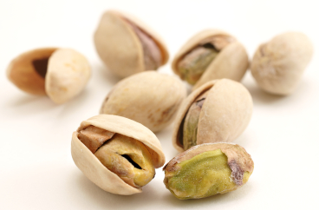

Chapter 3 – Case Studies



Case study 1: worked example

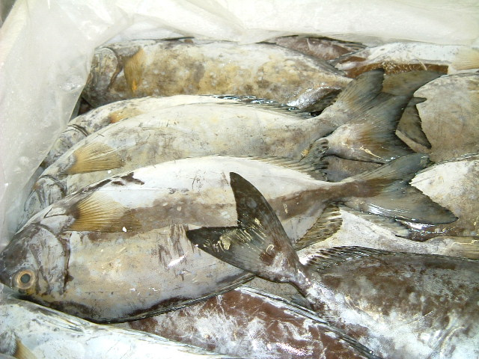
During an inspection of a retail shop, an authorised officer discovers a quantity of fish on display for sale in a chest freezer. The fish is unpackaged and there are no labels attached or associated with it.

Key Legal requirements

The fish should have originated from an approved establishment within an approved third country.

The packaging, in which the fish consignment arrived at the premises, should be marked with the country of origin and bear an establishment number.

A Common Health Entry Document (CHED-P) is required to be present at the first destination inland from the point of entry (BCP).

The Food Business Operator (FBO) should have adequate systems and procedures in place to demonstrate the traceability of food that he places on the market (Article 18 of Regulation (EC) No 178/2002).

The fish should be labelled with the name of the fish, the production method (whether caught at sea, inland or farmed) and the catch area: (The Fish Labelling Regulations (England) 2013) (S.I. 2013 No. 1768).

What are the concerns?

Fish should be properly labelled at the point of sale to provide the consumer with accurate information regarding its nature, origin and the method of catch employed. However, in this scenario the most significant concern is that the fish may have been illegally imported and as such has not been subjected to the necessary official controls. Here, the fish should have originated from an approved establishment in an approved third county and been imported into the EU via a designated Border Control Post (BCP) where a CHED-P should have been issued on completion of statutory import checks.

Fish handled in approved establishments in approved third countries which are subsequently checked at a BCP carry certain assurances as to the conditions in which they were produced and subsequently handled. In contrast, fish that may have originated from non-approved third countries and/or evaded border controls may pose a risk to public health.

Suggested course of action:

The authorised officer should firstly ask the FBO for further details in relation to the origin of the fish then seek to verify the accuracy and authenticity of such information.

The officer could request:

- To see invoices and/or delivery notes which relate to the fish
- Verbal information from the FBO regarding the supplier of the fish (Name, address, telephone/e-mail details)
- Whether the fish was imported directly by the food business where it is on sale.
- If this is the case, the officer should request a copy of the CHED-P.

The authorised officer should then consider the adequacy of the information provided.

Where the officer is satisfied that the fish originated from a third country but was not lawfully imported, a notice under Regulation 19 of the Trade in Animals and Related Products Regulations 2011 (TARP Regulations) should be served on the person in control of the food. This notice will require the seizure and destruction (or in exceptional circumstances re-export) of the food. For further details on this course of action see Chapter 2, Section 8.4 of this Resource Pack.

In circumstances where there is still doubt regarding the legitimacy of the fish, the authorised officer may consider placing the food under official detention in accordance with the provisions of Article 65, Regulation 2017/625. This can be achieved by issuing the person who appears to be in charge of the food with a letter of official detention an example of which can be found in Annex 1. The authorised officer should decide whether it would be appropriate to detain the food in the premises where it was found or remove the food and store it at a location specified in the letter.

Should the FBO provide information relating to the source country and /or establishment, the validity of these details may be verified by the officer with reference to the lists of approved countries and establishments.

Where the FBO is able to provide sufficient evidence to verify that the fish had been legally imported, he should be advised to ensure that all future consignments are adequately marked.

If a letter of official detention was served this can be withdrawn in writing.

If after initial investigation, the officer is unable to verify the legitimacy of the fish or has any technical queries, the FSA Imports Delivery Team should be contacted.

In accordance with the Food Law Code of Practice, should the authorised officer consider that the supply of the fish constitutes a serious local incident or a non-localised incident the matter must be reported to the FSA. This can now be achieved using the online incident report form which can be accessed at: https://www.food.gov.uk/contactbusinessesreport-safety-concern/report-a-food-safety-incident.

Case study 2

The following products are discovered during the routine inspection of a cut-price retail butcher’s shop:
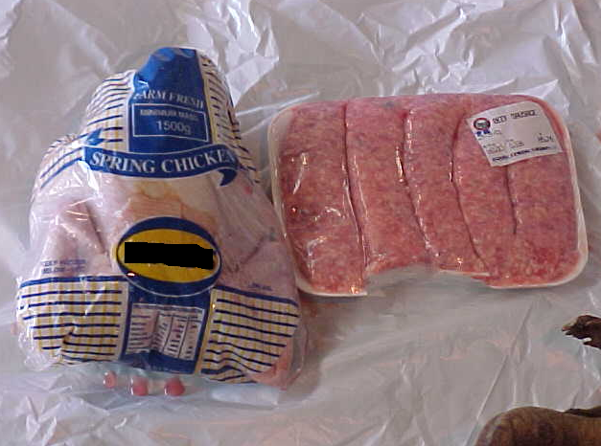
Chicken and beef sausages labelled “Product of RSA”

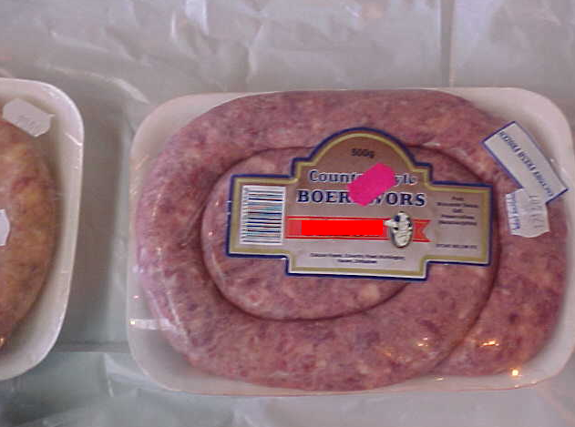
“Factory fresh frozen” “Boerewors sausages – Product of RSA”

- What information would you look for on the packaging?

- What questions do you ask the butcher?

- What legislation would you review in respect of this food?

d) What are the potential enforcement options available to you?

Case study 3

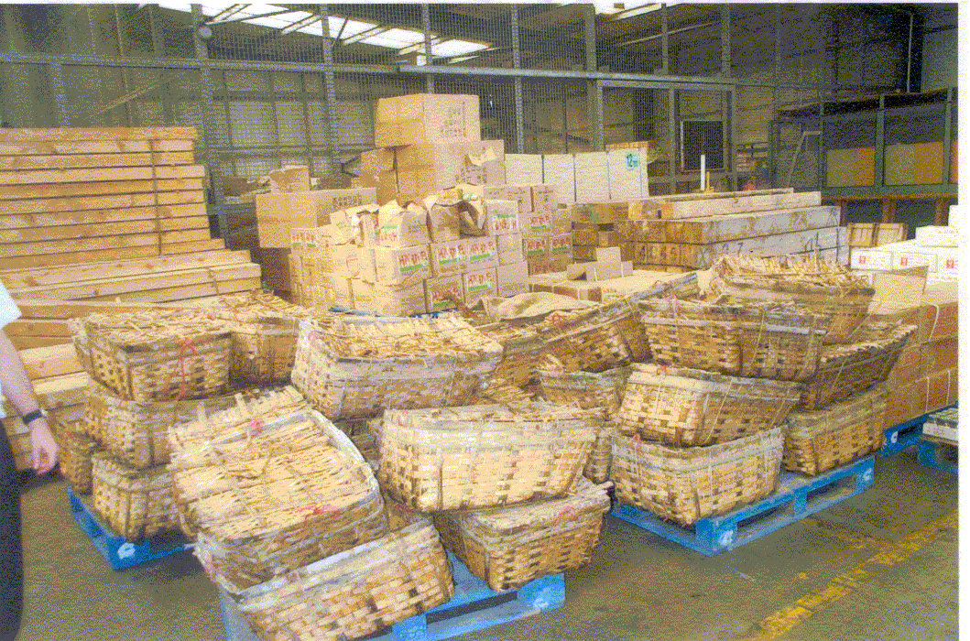
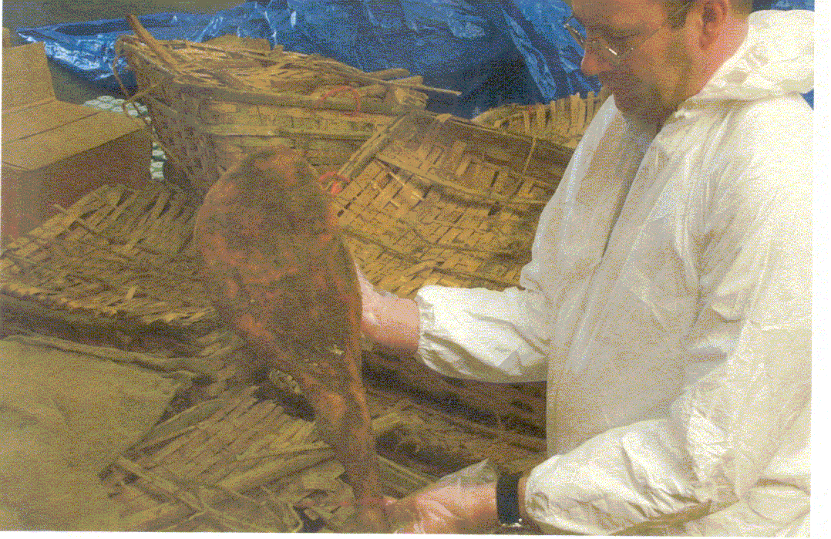

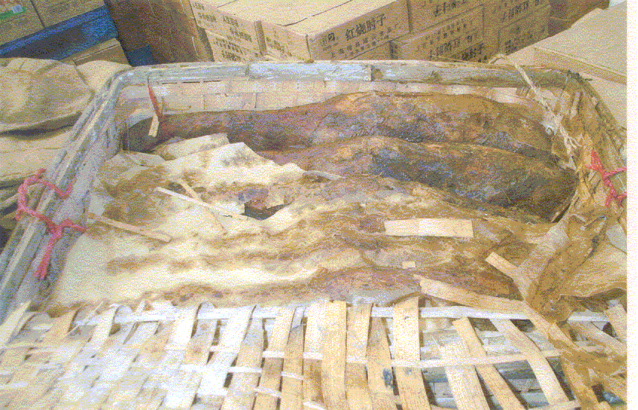

You have established that there is an ETSF in your district that you were previously unaware of. You decide to visit the premises. During the visit, it is clear from paperwork that large quantities of fruit and vegetables routinely obtain HMRC clearance at this ETSF. Whilst inspecting some pallets of fruit you come across the items shown in the pictures.

- What investigation work should you undertake?

- What formal action is appropriate?

- Who should you contact if you are unsure on how to proceed?

- What follow up work do you undertake?

Case study 4
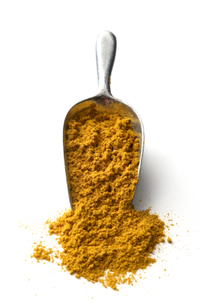
As a part of your council’s sampling programme this year, you are expected to procure samples of various spices for analysis or examination. You visit a warehouse owned by a company that imports animal and non-animal products from around the world. You choose to take a sample of curry powder imported from India.

- Explain how this product can be imported legitimately into the UK.

- What documents should be present at the first point of import for this product?

- What action should you take if you suspect that this product has not been legitimately imported?

- What contaminants would you ask the Public Analyst to look for?

e) What action would you take if the analyst finds unacceptable levels of contaminants?

Case study 5

(This comes in two parts. When you have finished work on part one please work on part two).

Part 1: You are investigating an outbreak of Salmonella food poisoning in your district. Initial findings suggest that the source may be associated with a sandwich bar in your district and, in particular, coronation chicken sandwiches.

- What ingredients of the sandwiches could be possible sources of the salmonella contamination?

- What action would you take?

- What guidance/legislation might be appropriate for you to consider in this case?
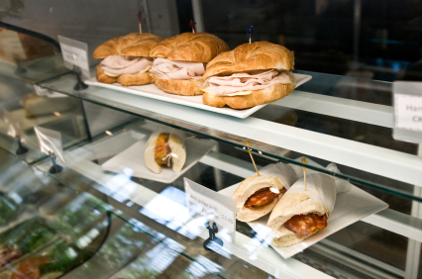
Part 2: ADDITIONAL INFORMATION – The Salmonella species and phage type has been confirmed by Public Health England’s (PHE) public health laboratories. You originally took samples of chicken, curry powder and swabs from preparation surfaces and containers. The microbiological results are received by you as follows:

Ref: XGF836201
MICROBIOLOGICAL REPORT Lab Number: EF005127

Sender: Council Sample From: Tasty Sarny Co.

Seal Nos: 2113948, 2113949, 2113950, 2113951, 2113952, 2113953

Sample No | Specimen | Salmonella Spp. | Comments
1 | Chicken pieces -  (Sealed outer) | Not detected in 25g | Acceptable
2 | Curry powder | Present in 25g | Unacceptable | Potentially  hazardous
3 | Swab A | Not Detected
4 | Swab B | Not Detected
5 | Curry powder -  Container swab | Present | Unacceptable
6 | Chicken -  Container | Not detected | Acceptable swab

SAMPLE 2 confirmed presence of Salmonella Spp X phage type Y in 25g. [Positive match to pathogen retrieved from stool samples].

----------REPORT ENDS--------------

- Outline your actions following receipt of these results.

- Following further investigation it appears that the curry powder was originally imported as a bulk consignment for distribution across the EU. It was Customs cleared at Rotterdam Freeport in the Netherlands. What follow up action do you take and what channels of communication do you use?

Imported Food Case Study Model Answers:

Please note that these are suggested answers for educational purposes only. Alternative enforcement strategies and processes may be appropriate dependant on specific circumstances encountered and enforcement officers are advised to seek appropriate advice prior to embarking on a specific course of action.

Model answer: Case study 2

- As a minimum you should note:

- Product description.
- Product brand.
- Weight.
- Country of Origin.
- EU Approval number.

However, if investigating such a product you should really make notes on all information that is available and consider taking a sample. Samples would be taken under regulation 34(g) of the TARP Regulations and should be used if you need to carry out further identity or physical checks on the product.

Information could include:

- Durability markings.
- Producer details.
- Importer details.
- Description of condition of product.
- All other labelling/markings.

If you intend to contact the FSA, Defra, HMRC (or other Government departments) then it is really helpful to take digital photographs that can be e-mailed in to assist with identification/details of your enquiry.

b) Questioning should initially be general to gain an understanding of the scope of imported food trade at this business. Try to identify the following:

- What range of imported food products is currently on the premises/purchased by the business/stored elsewhere?
- How does the retailer receive imported foods? Is this by direct import or purchase from a wholesaler? If a wholesaler, or other intermediary, obtain details.
- Does the retailer sell any product on to other stores or are there any other associated outlets?

Then focus in on the product in question and obtain more detail:

- Who is in charge of goods?
- Who owns goods?
- Who imported these specific goods?
- Which BCP/Port were they imported through?
- Is this commodity a regular import?
- Who is the supplier (GB/ third country)?
- Do you supply these goods onwards?
- Do you have or can you obtain the CHED-P?
- What date were the goods imported? (Although difficult to obtain, sometimes this may be crucial, if specific safeguard controls were in force at the time of import, e.g. veterinary residue controls).
- What quantity of stock is held?
- Ask for commercial documents to verify (invoices, shipping documents).
- If unfamiliar with the product ask what it is used for and obtain general information relating to the product type.
- Where were the goods purchased?
- When were they purchased?
- Is this a regular stock line?

Detailed questioning may then follow dependant on answers provided. The core information that is needed to verify it is a legitimate import is:

- (Copy of) Common Health Entry Document.
- Date of import.
- Place of import.
- Approved establishment number and country of origin.
- Type of product.

In some cases it will be a lengthy process to obtain this information (especially when from a small retailer, who is some way down a complex distribution chain). Of course, you will need to investigate in line with enforcement policies and it may not be proportionate to carry out a detailed investigation on each occasion that you find goods of this nature. However, where you have grounds to suspect that goods are illegal imports you should follow up with an investigation and enforcement activity, as appropriate. The traceability requirements of Regulation (EC) No 178/2002 (implemented by the Food Safety and Hygiene (England) Regulations 2013) may be of assistance in tracing back to the CHED-P. You may need to liaise with other LAs or PHAs to obtain the information.

c) Legislation to Review:

- The Trade in Animals and Related Products (TARP) Regulations 2011
- Good answers will include reference to checking on safeguard provisions in place at the time of import, i.e. specific Commission Decisions and Declarations under Regulation 29 of the TARP Regulations. These can be found on Defra and FSA’s websites and officers are recommended to keep up to date with countries subject to safeguard provisions and related issues. This need not be in full technical detail needed by BCP staff but just to be aware of current issues

d) Potential Enforcement Options:

This legislation should be considered first as it is most pertinent to deal with illegal third country POAO imports and offers a number of robust enforcement procedures:

- TARP Regulations – regulation 19 – Enforcement procedure for illegally imported animal products.

If it is inappropriate to act under the above or disproportionate to carry out a lengthy investigation and there are other food safety/standards offences, then consider action under the Food Safety Act 1990 and related S.I.s.

If an authorised officer considers that it would be necessary to detain the food pending further investigation, then a letter of official detention as provided in Annex 1 might be considered.

Finally, where action is taken against illegal imported animal products it is important that intelligence information is passed to the LA/PHA officers at the point of entry. The FSA National Food Crime Unit will ensure that HMRC and BF are informed as well as recording the information.

Model answer: Case study 3

- Initially investigation work will be limited to establishing the origin of the poorly packaged decaying meat. It is important at this stage to identify if the products have been imported from third countries. If they are third country imports verify that health marks are absent and that the goods have not been presented to a BCP, with subsequent issue of a CHED-P. Also, it is important to establish if any of the product has been dispatched elsewhere so that it may be tracked and controlled. As this facility is under customs control, being an ETSF, the formal control of the smuggled meat will be the responsibility of BF.

- You should refer the case to BF via local liaison, if in place or via the Border Force National Intelligence Hub on Tel. 03000 583 016 or by e-mail at:
UKBFNationalIntelligenceHub@homeoffice.gsi.gov.uk

In order to help BF prioritise their response, professional judgement should be used as to whether goods can be left unattended or not. Risk factors should be communicated to HMRC such as:

- likelihood that the goods will be removed if left unsecured.

- perceived level of risk presented by the commodity. In this example the ham may present high animal health risk as a potential vector of animal disease and may have associated public health risks due to the condition of the product. If high risk is identified, the LA should urge HMRC to attend as soon as possible and remain with the goods or secure them in a locked area, if practicable.

If there is a perceived high risk, it is imperative to ensure that the goods are controlled and do not leave the premises by service of a regulation 32(6) TARP Regulation notice to detain the food for referral to BF would be appropriate. Additionally, great care needs to be taken to ensure that all steps are taken to prevent contact with the product and spread of potential contaminants. You should ensure that a health and safety risk assessment is in place in relation to the activities of LA personnel and any contractors etc. Finally, the local APHA office must be informed so that they can consider possible risk to animal health in the area.

In other cases where the risks posed may not be so high, and where you have confidence in the management you should indicate to BF that the response needed is not immediate but is nonetheless still reasonably urgent. BF will endeavour to respond within 24 hours for all incidents.

Additionally, if you have established that goods have moved away from the ETSF to your jurisdiction, or the jurisdiction of other LAs, you should ensure that the rest of the consignment is intercepted and seized using a TARP Regulation 19 notice.

- If unsure how to proceed then contact the relevant organisation as per the information in this Pack. However, if you are unclear or do not have numbers available to you on site, please e-mail the FSA Imported Food Team at imported.food@food.gov.uk and we will pass you to the right person to assist.

- Follow up work will largely involve liaison with BF to ensure that the entire consignment has been seized whether in BF or LA jurisdiction. Also, you should send copies of any notices served under the TARP Regulations to Defra.

You should report the seizures to Defra using the IIT1 form. The reporting of seizures by LAs/PHAs requires the completion (preferably electronically) of a common form (IIT 1 (4/08), which is then sent by e-mail for Defra to record the appropriate information required. However, the option remains for the form to be completed manually, if that method is preferred, and sent to Defra by fax/post. Details of where to e-mail/fax/post the form is included on the form itself. As you know the form is located on the secure parts of the following websites which cannot be accessed without password permission:

APHA: http://www.porthealthassociation.co.uk/
CIEH: http://www.ehcnet4.net/govt/defra/iit/iitrept.php

The information provided in this form is also shared with the Food Standard Agency’s National Food Crime Unit.

If the meat has been widely distributed, then you should notify FSA so that they can assist you with submission of RASFF notifications and issue food alerts as may be appropriate to the circumstances.

Model answer: Case study 4

- Curry powder containing chillies from India is currently identified as a “higher risk” FNAO in Annex II of Regulation 2019/1793(as amended) and should only be imported via a Border Control Post (BCP). Legitimate import requires the FBO to pre-notify the BCP of its arrival and for enhanced checks to be undertaken at the port. The consignment should be accompanied by an Official Certificate as well as results of sampling and analysis.

- A properly completed, signed and stamped Common Health Entry Document (CHED) should be available at the first point of entry inland.

- After suitable consultation, a detention notice should be served under regulation 32 of the Official Feed and Food Controls Regulations (England) 2009 (as amended).

- You may wish to consider examination or analysis for Salmonella, mycotoxins and other contaminants that may be associated with this commodity.

- Destruction - Regulation 32 of the Official Feed and Food Controls Regulations (England) 2009 (as amended).

Model answer: Case study 5

- Chicken, mayonnaise, eggs, salad dressings, lettuce/salad, infected handlers, contaminated surfaces, cross-contamination and curry powder.

- Food Safety Act 1990, Regulation (EC) No 852/2004 (Hygiene of Foodstuffs), Food Hygiene Regulations (England) 2013 (as amended), local outbreak control plans and related information/legislation, PHLS Guidelines for the microbiological quality of some ready-to-eat foods. (This list is not exhaustive but indicates some of the more obvious documents).

- Clearly from the results, the curry powder is the most likely source of the problem. Hence, alongside ‘normal’ outbreak control work to minimise the impact on the general population, the distribution of the curry powder needs to be established and controlled. The extent of distribution both upstream and downstream should be established along with any distinguishing marks, lot numbers, batch codes, etc. Details of supplying and receiving establishments should be identified and the case should be referred to FSA’s Food Incidents Team on 020 7276 8448 or via email to FoodIncidents@food.gov.uk or by completion of the online report form at: https://www.food.gov.uk/contact/businesses/report-safety-concern/report-a-food-safety-incident. Control will be via the Food Safety Act 1990. (Imports legislation would not normally be appropriate once imported goods have been legitimately HMRC cleared into GB – if in any doubt ask for advice).

- All enquiries on notifications to the FSA’s in Food Incidents Team on 020 7276 8448.

- The country of origin and whether or not the curry powder contains chillies will need to be determined. If the curry powder is covered by Regulation 2019/1793 (as amended), you will need to investigate if it was imported correctly through Rotterdam by CHED, the Food Business Operator, importer or the BCP in Rotterdam should be contacted for this information.

Chapter 4 – References



Section 1: Glossary

APHA | Animal and Plant Health Agency (APHA)
Airway bill | Commercial documents providing a general description of air cargo items
APHA | Association of Port Health Authorities
BF | Border Force
BCP | Border Control Post situated at a seaport or airport or international rail or road link. This is the port of entry, where POAO and controlled PNOAO may be legitimately imported. The POAO and controlled PNOAO will be subjected to official checks at the BCP and a CHED-P will be issued to demonstrate that these checks have been successfully completed.
CCA | Central Competent Authority. In England, Defra is the CA for the import of POAO from third countries except for fishery products and shellfish where the FSA is the CCA.
CA | Competent Authority
CHED | Common Health Entry Document – Part II of this document is issued at a BCP to verify that a “higher risk” FNAO and POAO has been lawfully imported.
CEFAS | Centre for Environment, Fisheries and Aquaculture Science
CHIEF | Customs Handling of Import and Export Freight
CIEH | Chartered Institute of Environmental Health
CITES | Convention on International Trade in Endangered Species
Consignment(s) | A consignment is a quantity of food or feed of the same type, class or description covered by the same document(s), conveyed by the same means of transport and coming from the same third country or part of such country.
Code of Practice | Code of Practice issued under the Food Safety Act 1990, the Food Safety and Hygiene (England) Regulations () 2013 and the Official Feed and Food Controls Regulations (England) 2009 (as amended).
Defra | Department for Environment, Food and Rural Affairs.
Demurrage | Charges for use of shipping containers, rail wagons, tanker lorries waiting for pick up or clearance, storage charges for space on a dock or wharf or in transit sheds and elsewhere. Akin to rental excess charge for use past the agreed period.
ETSF | External Temporary Storage Facility (HMRC designated warehouse where goods are held in temporary storage pending Customs clearance and release for free circulation).
FNAO | Food Not of Animal Origin
Free Circulation | Customs status for goods that are 'cleared' into GB
FSA | Food Standards Agency
HMRC | Her Majesty's Revenue & Customs
IIT | Inspections and Investigations Team
LA | Local Authority
Manifest | Document/computer file describing all cargo carried on a ship, cargo train or aircraft.
MHRA | Medicines and Healthcare Products Regulatory Agency (Formerly MCA – Medicines Control Agency)
MCA | Maritime and Coastguard Agency
MoU | Memorandum of Understanding
NCH | National Clearance Hub (HMRC)
OFFC | Official Controls performed to ensure compliance with Food & Feed Law, Animal Health and Welfare Rules
OFI | Official Fish Inspector
OVS | Official Veterinary Surgeon
PHA | Port Health Authority
POAO | Products Of Animal Origin
RASFF | Rapid Alert System for Food and Feed (EU)
S.I. | Statutory Instrument
TARP Regulations | Trade in Animals and Related Products Regulations 2011
Third Country | Any country outside of the GB for the purposes of import controls
Trans-shipment | Movement of goods from HMRC area of a port to another port
VMD | Veterinary Medicines Directorate

Section 2: Useful links

Relevant Organisations/Central Government Departments

The Association of Port Health Authorities (APHA) website | http://www.porthealthassociation.co.uk/
The Chartered Institute of Environmental Health (CIEH) website | http://www.cieh.org/
Centre for Environment, Fisheries and Aquaculture Science (CEFAS - executive agency of Defra) website | https://www.cefas.co.uk/
Defra Organic Farming Branch – Organic imports Homepage | https://www.gov.uk/guidance/organic-products-import-them-into-the-uk
The Food and Environment Research Agency (FERA) website | http://www.fera.defra.gov.uk/
Plant Health – APHA | https://www.gov.uk/guidance/plant-health-controls
Chemicals Regulation Directorate (CRD formerly PSD) website | http://www.hse.gov.uk/crd/
Veterinary Medicines Directorate (VMD) website | https://www.gov.uk/government/organisations/veterinary-medicines-directorate
General information

Customs Tariff/Commodity Codes on-line | https://www.trade-tariff.service.gov.uk/trade-tariff/sections
Legislation Homepage (formerly Office of Public Sector Information OPSI) | http://www.legislation.gov.uk/
Food and Agriculture Organization - Fisheries Global Information System (Identification of fish etc.) | http://www.fao.org/fi/figis/index.jsp
The Food Standards Agency (FSA) website | http://www.food.gov.uk
The imported food section of the Food  Standards Agency website | https://www.food.gov.uk/business-guidance/imports-exports
Foodstuffs with current restrictions (Please note the list is subject for review biannually; whereby products are added and removed.) | https://www.food.gov.uk/sites/default/files/media/document/table-of-foodstuffs-with-current-eu-restrictions_1.pdf
Banned or Restricted products | https://www.food.gov.uk/business-guidance/importing-high-risk-food-and-feed
Products of Animal Origin information

Border Inspection Post Manual – Veterinary Checks | http://apha.defra.gov.uk/official-vets/Guidance/bip/manual.htm
List of UK Border Control Posts Homepage | https://www.gov.uk/government/publications/uk-border-inspection-posts-contact-details/live-animals-and-animal-products-border-control-posts-bcp-in-the-uk
Defra guidance on importing and exporting animal and animal products | http://www.defra.gov.uk/animal-trade/
Defra personal imports information | http://www.defra.gov.uk/food-farm/food/personal-imports/
CIEH (Authorisation required) | http://www.ehcnet4.net/govt/defra/iit/iitrept.php
UK and relevant EU Legislation (Please note: Some of this legislation will have been reviewed and updated – the links are to original unamended versions)

The Animal By-Products (Enforcement)(England) Regulations 2013  SI no 2952 | http://www.legislation.gov.uk/uksi/2013/2952/pdfs/uksi_20132952_en.pdf
The Contaminants in Food (England) Regulations 2013 S.I. no. 2196 | http://www.legislation.gov.uk/uksi/2013/2196/pdfs/uksi_20132196_en.pdf
The Food Labelling Regulations 1996 S.I. no.  1499 | http://www.legislation.gov.uk/uksi/1996/1499/contents/made#tcon
The Food Safety Act 1990 | http://www.legislation.gov.uk/ukpga/1990/16/contents
Regulation (EC) No 178/2002 (the general food law) | http://eur-lex.europa.eu/LexUriServ/LexUriServ.do?uri=CONSLEG:2002R0178:20090807:EN:PDF
The Official Feed and Food Control (England) Regulations 2009 S.I. no. 3255 (as amended) | http://www.legislation.gov.uk/uksi/2009/3255/contents/made
The Trade in Animals and Related Products Regulations 2011  SI no 1197 | http://www.legislation.gov.uk/uksi/2011/1197/contents/made
Regulation (EU) 2017/625 of the European Parliament and of the Council of 15 March 2017 on official controls and other official activities performed to ensure the application of food and feed law, rules on animal health and welfare, plant health and plant protection products | https://eur-lex.europa.eu/legal-content/EN/TXT/PDF/?uri=CELEX:02017R0625-20191214&qid=1589801489749&from=EN
PHA and LA Contacts

Contact details for all of the UK ports are available on the Association of Port Health Authorities website at: http://www.porthealthassociation.co.uk/port-directory/
Alternatively, these contact details can be found in the Association of Port Health Authorities Handbook (updated annually). APHA can be contacted at: info@apha.org.uk

For LAs please refer to either the Directory of Environmental Health Departments (including Port Health Authorities) or, for Trading Standards Departments, to the website: https://www.gov.uk/find-local-trading-standards-office

Section 3: National Contacts:

Issue | Organisation | Contact | Tel: | E-mail
Imported Food General, POAO (Fish), Public Health Controls, Enforcement support | FSA | Imported Food Team | 020 7276 8018 | imported.food@food.gov.uk
Trade sample licences (inc. fishery products/bivalve molluscs), Trade Enquiries POAO | Animal and Plant Health Agency (APHA) |  | 01228 403 600 (option 3) | imports@apha.gov.uk
POAO (Not Fishery products/bivalve molluscs), animal health issues, Enforcement support. | Animal and Plant Health Agency (APHA |  | 01228 403 600 (option 3) | imports@apha.gov.uk
Illegal POAO imports general enquiries | Defra | Imports and EU Trade Team |  | ImportsTradeinAnimalsandProducts@defra.gov.uk
Queries/referrals for illegal imports  Intelligence reports to Customs (5x5x5) | Border Force | Border Force National Intelligence Hub | 03000 583 016 | UKBFNationalIntelligenceHub@homeoffice.gov.uk

Regulation 13 – The Trade in Animals and Related Products Regulations 2011 (SI. 1197/2011)

